Assignment -4

SmartFarmer - IoT Enabled Smart Farming

Application

Assignment Date | 17 October 2022
Student Name | Hari Prasath .V
Student Roll Number | 910619106020
Maximum Marks | 2 Marks

Question-1:

Write code and connections in wokwi for the ultrasonic sensor. Whenever the distance is less than 100 cms send an "alert" to the IBM cloud and display in the device recent events. Upload document with wokwi share link and images of IBM cloud

CODE 1 :

#include <WiFi.h>

#include <PubSubClient.h>

void callback(char* subscribetopic, byte* payload, unsigned int payloadLength);

#define ORG "i3lxgz"

#define DEVICE_TYPE "ESP32"

#define DEVICE_ID "06020"

#define TOKEN "123456789"

String data3;

char server[] = ORG ".messaging.internetofthings.ibmcloud.com"; char publishTopic[] = "iot-2/evt/Data/fmt/json";

char subscribetopic[] = "iot-2/cmd/test/fmt/String"; char authMethod[] = "use-token-auth"; char token[] = TOKEN;

char clientId[] = "d:" ORG ":" DEVICE_TYPE ":" DEVICE_ID; WiFiClient wifiClient;

PubSubClient client(server, 1883, callback ,wifiClient);

const int trigPin = 5;

const int echoPin = 18;

#define SOUND_SPEED 0.034

long duration;

float distance;

void setup() {

Serial.begin(115200);

pinMode(trigPin, OUTPUT);

pinMode(echoPin, INPUT);

wificonnect();

mqttconnect();

}

void loop()

{

digitalWrite(trigPin, LOW);

delayMicroseconds(2);

digitalWrite(trigPin, HIGH);

delayMicroseconds(10);

digitalWrite(trigPin, LOW);

duration = pulseIn(echoPin, HIGH);

distance = duration * SOUND_SPEED/2;

Serial.print("Distance (cm): ");

Serial.println(distance);

if(distance<100)

{

Serial.println("ALERT!!");

delay(1000);

PublishData(distance);
delay(1000);

if (!client.loop()) {

mqttconnect();

}

}

delay(1000);

}

void PublishData(float dist) {

mqttconnect();

String payload = "{\"Distance\":";

payload += dist;

payload += ",\"ALERT!!\":""\"Distance less than 100cms\""; payload += "}";

Serial.print("Sending payload: ");

Serial.println(payload);

if (client.publish(publishTopic, (char*) payload.c_str())) { Serial.println("Publish ok");

} else {

Serial.println("Publish failed");

}

}

void mqttconnect() {

if (!client.connected()) {

Serial.print("Reconnecting client to ");

Serial.println(server);

while (!!!client.connect(clientId, authMethod, token)) { Serial.print(".");

delay(500);

}

initManagedDevice();

Serial.println();

}

}

void wificonnect()

{

Serial.println();

Serial.print("Connecting to ");

WiFi.begin("Wokwi-GUEST", "", 6);

while (WiFi.status() != WL_CONNECTED) {

delay(500);

Serial.print(".");

}

Serial.println("");

Serial.println("WiFi connected");

Serial.println("IP address: ");

Serial.println(WiFi.localIP());

}

void initManagedDevice() {

if (client.subscribe(subscribetopic)) {

Serial.println((subscribetopic));

Serial.println("subscribe to cmd OK");

} else {

Serial.println("subscribe to cmd FAILED");

}

}

void callback(char* subscribetopic, byte* payload, unsigned int payloadLength)

{

Serial.print("callback invoked for topic: ");

Serial.println(subscribetopic);

for (int i = 0; i < payloadLength; i++)

{

data3 += (char)payload[i];

}

Serial.println("data: "+ data3);

data3="";

}
Wokwi Link :
https://wokwi.com/projects/346865633302938195

Output and Simulation :
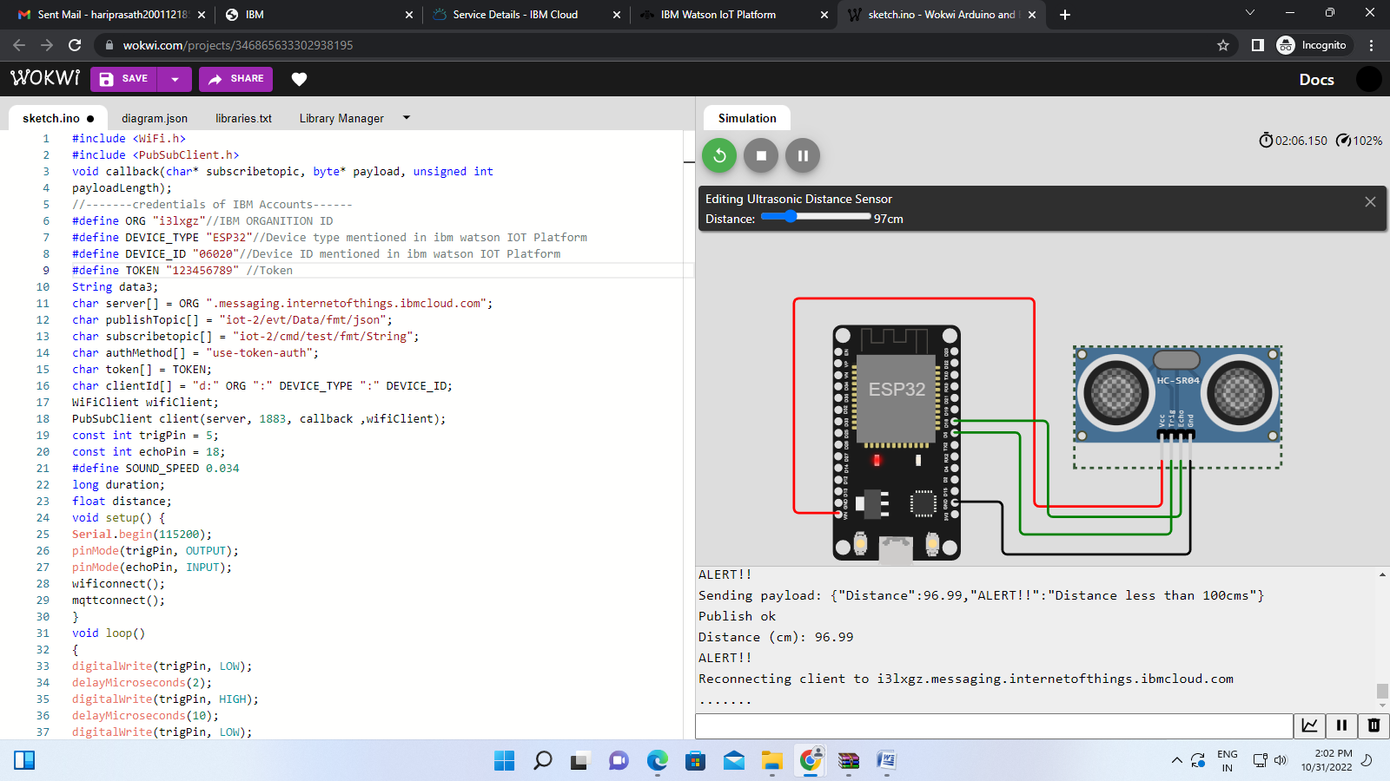

Whenever the distance is less than 100 cms send an "alert" to the IBM cloud and display in the device recent events.

